**SCMS School of Technology and Management**

**Prathap Nagar, Muttom, Cochin**

|  |  |
| --- | --- |
| **NAME OF THE HOSTING DEPARTMENT** | Department of Management |
| **Name of the Faculty coordinator(s)** | Dr. Deepa Babu K G  Dr. Vilas Nair |
| **Name of the Student coordinator(s)** | Mr. Aadith S Manikandan  Ms. Aleena k francis |
| **Name of the Event** | Integrated Management Learning Programme (IMLP) |
| **Date & Time** | 8-08-2024, THURSDAY |
| **Venue** | SCMS Seminar Hall |
| **Resource Person/ Organisation** | SCMS School of Technology and Management |
| **Participants**  **(Inclusive of participants number):** | Students of MBA B22 (115) |
| **Event description** | The program was started at 9 15 am with a prayer and the judges are from PGDM department without any further dew the first team presented and it was really interesting all teams announced their group names and their logo. There were total of 14 groups each group has unique and interesting names. Each group got a total time of 7 minutes for their presentation and 3 minutes for question- and- answer session. All faculties were there in order to support the students. The program ended at 1 pm and the result will be announced at the next IMLP session. |

**Pictures:**

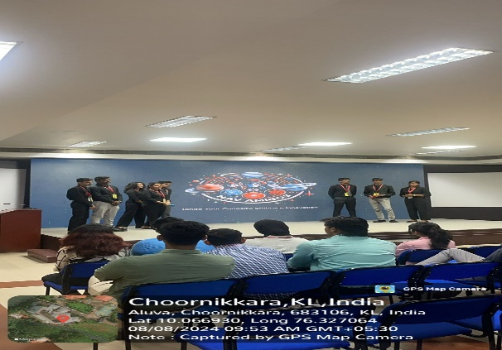

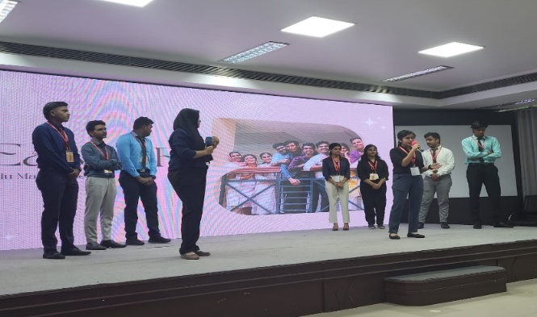

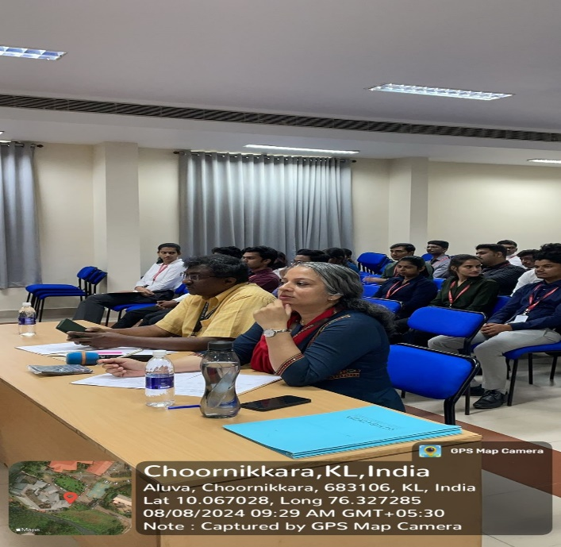

**Signature of the Faculty College Signature of the Principal**

**Event Coordinator Seal**